MTH2010 Readings and Assignments: Week 5

Week 5 Readings
As early in the week as possible, please read:
- Week 5 and Week 6 online lectures.
- The following sections from the Chapter 8 (Surfaces and Solids) of the text Elementary Geometry:
  - Section 8.1 pg. 390-399 (Also read examples 1-8),
  - Section 8.2 pg. 399-410 (Also read examples 1-7),
  - Section 8.3 pg. 410-419 (Also read examples 1-6),
  - Section 8.4 pg. 419-429 (Also read examples 1-8. Refer to table 8.4 on the page 431 for a summary of the formulas.)
- The following sections from the Chapter 9 (Analytical Geometry) of the text Elementary Geometry:
  - Section 9.1 pg. 436-443 (Also read examples 1-6),
  - Section 9.2 pg. 444-452 (Also read examples 1-10), and
  - Section 9.3 pg. 453-461 (Also read examples 1-9).
Week 5 Assignments Overview
Assignment Summary Week 5: | Due Date
Assignment 1: Discussion Questions | Friday, March 20, 2009
Assignment 2: Exam | Sunday, March 22, 2009
Assignment 3: Discussion on Exam | Monday, March 23, 2009
Using the navigation on the left, please proceed to the next page.

Week 5

Learning Outcomes:
- Recognize three-dimensional solids.
- Identify different types of prisms and pyramids.
- Calculate areas and volumes of prisms and pyramids.
- Calculate surface areas and volumes of cylinders, cones, and spheres.

Surfaces and Solids
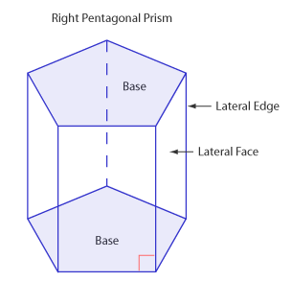
This week, you will deal with a type of geometry known as solid geometry. You will be working with surface areas of solids with polygonal or circular bases and find volumes for these solid figures.
In working with solid figures, you will need to shift your attention to the three-dimensional world from the one-dimensional world of the point and line, and the two-dimensional world of the plane. We now add depth to the figures, and we have to be able to visualize these solids. You will be dealing with solid figures such as prisms, pyramids, cones, cylinders, and cubes.

Prisms
A prism is a solid figure that contains two bases and three or more lateral faces. The shape of the base gives the prism its name; for example, the right triangular, right rectangular, oblique square, oblique pentagonal, right hexagonal, etc. The bases of a prism are congruent polygons that lie in parallel planes. The altitude of a prism is a line segment that is also the height, which joins the two base planes of the prism and which is perpendicular to both. The lateral faces of a prism are the faces of the prism that are not its bases. Adjacent lateral faces intersect in parallel segments called lateral edges. To find the area of a prism, we find the sum of all the lateral faces.
- The amount of space that a solid encloses is represented by its volume.
- The volume of a solid, expressed in cubic units, is the number of cubes having an edge length of 1 unit that the solid can enclose.
- Now, we have a prism, which is a solid, and the prism encloses a portion of space.
- The volume (V) of any prism is equal to the product of the area of its base (B) and its height (h): V = Bh.
- A rectangular solid is a prism whose two bases and four lateral faces are rectangles.
- So, the volume of a rectangular solid is equal to the area of the base which is length(l) times width(w), multiplied by the height (h): V = Bh = lwh.
- Similarly, if the prism has the bases and lateral faces that are squares, it's called a cube, and the volume of the cube is length (l) times width, which is also equal to its length (l), and then multiplied by its height.
- The height is also equal to its length (l). So V = Bh = .

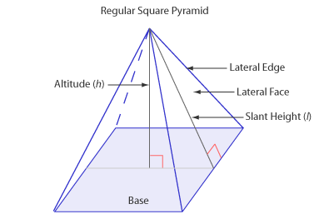
Pyramids: Area and Volume
A regular pyramid is a shape that has a regular polygon for a base, congruent lateral edges, and lateral faces that are congruent isosceles triangles. The altitude of a pyramid is a line segment perpendicular to the base drawn from the vertex of the pyramid. Its length is the height of the pyramid, usually identified as h. As with prisms, the name of a pyramid follows the shape of its base. For example, you may come across a square pyramid, a pentagonal pyramid, a hexagonal pyramid, etc. A regular pyramid will also have what we refer to as slant height. The slant height of a pyramid is the height of a lateral face of the regular pyramid and it is usually identified as l.
- The lateral area L of a regular pyramid can be found by adding the areas of the triangular lateral faces.
- Given that P is the perimeter of the base of the pyramid, and l is the slant height, the formula for the lateral area L of a pyramid is: L = ½ lP.
- The total area or surface area T of a pyramid with lateral area L and base area B is given by T = L + B.
- The surface area is the sum of the areas of all the pyramids faces.
- The volume of a pyramid is equal to the product of one-third the area of the base B and the height (h) of the pyramid (V = 1/3 Bh).

Cylinders and Cones

Cylinders
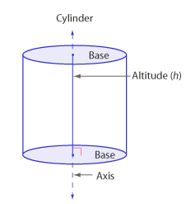
A cylinder has two bases that are congruent circles lying in parallel planes. It is a shape similar to a prism with the exception that its bases are circles instead of polygons. The altitude of a right cylinder is the line segment that joins the center of both circular bases and which is perpendicular to both.
- The lateral area L of a right circular cylinder is equal to the product of its altitude h and the circumference C of its base, L = hC.
- And recall that the circumference of a circle is given by 2r. So in other words, L = 2rh.
- For the surface area, we have to include the area of the bases. We have the lateral area, and the area of each of the two circular bases. Therefore, the total area T = L + 2B = 2rh + 2r².
- Like the volume of a prism (a solid that also has two congruent bases), the volume of a cylinder is equal to the product of the area of a base B and the height of the cylinder h.
- Since the base is a circle, the area of the base of a cylinder isr².
So, the volume V of a cylinder is V=r²h.

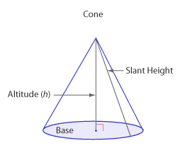
Cones
A cone is a shape similar to a pyramid with the exception that its base is a circle instead of a polygon. The altitude of a cone is the line segment that is drawn from the vertex of the cone to the base and is perpendicular to the base. As with a pyramid, we also have a slant height for the cone. The slant height of a cone is any line segment that joins the vertex to a point on the circle.
- The lateral area of a right circular cone with length l and circumference C of the base is given by L = ½ lC = rl.
- The total area or surface area of a cone is the sum of the area of the base and the lateral area of the cone, T = B + L = r² +rl.
- For the volume of a cone, recall that the volume of a pyramid is V = 1/3 Bh.
- In this case, B is the area of the base. For a cone, the area of its base is r².
- So, the formula for the volume of a cone can be written as V = 1/3 r²h.

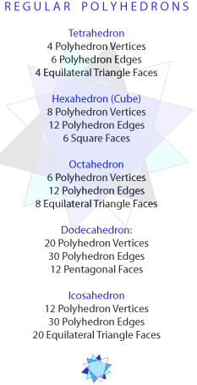
Polyhedrons and Spheres

Polyhedrons
A polyhedron is a solid bounded by plane regions. The faces of the solid are formed by polygons and the segments common to the polygons make up the edges of the polyhedron. Your focus will be on the regular polyhedron and there are five polyhedra that you need to know of: regular tetrahedron, regular hexahedron, regular octahedron, regular dodecahedron, and regular icosahedron. As you can see, the names of the polyhedrons are based on the number of the faces that it has.
One can find the number of faces F or the number of edges E of a polyhedron if the number of vertices V were known. According to Euler's equation, the number of vertices, the number of edges, and the number of faces of a polyhedron, are all related by the equation V + F = E + 2.

Spheres
A sphere is another type of solid and it is a solid that represents the set of all points in space that are at a given distance from a fixed point. The fixed point O, is the center of the sphere.
The distance r then is the radius of the sphere. The surface area S of a sphere with radius r is given by S = 4r². The volume of the sphere is given by V = 4/3r³.

Assignment 1: Discussion Questions
By Friday, March 20, 2009, choose two of the discussion questions, and post your responses in the Discussion Area. Your response should reflect an understanding of the material covered as it applies to your life, work, and educational experiences. Start reviewing and responding to your classmates as early in the week as possible; post comments on at least two of your classmates' submissions to the Discussion Area. Please refer to the policy for participation found in the Educational Commitment Statement.
Grading Criteria | Maximum Points
Correct explanation of concepts. | 4
Well-formed conclusions. | 4
Participation in discussion with class, feedback, and comments. | 4
Correct spelling and grammar. | 4
Total: | 16
For assistance with any problems you may have when completing this assignment—OR—to offer your assistance to classmates, please use the Problems and Solutions Discussion area located through the left side navigation link.
DQ 3: Describe how you would find the volume of an ice cream cone that is completely filled with ice cream. Assume that the ice cream above the cone has the shape of a hemisphere.
DQ4: Make comparisons between the shape of the earth and the sphere. Describe the similarities or differences, if any.
DQ5: A drug manufacturing company wants to manufacture a capsule that contains a spherical pill inside. The diameter of the pill is 4mm and the capsule is cylindrical, with hemispheres on either end. The length of the capsule between the two hemispheres is 10mm. Describe how we could find the exact volume the capsule will hold, excluding the volume of the pill. What is the value that you get from your calculation? Why is it important for us to be able to determine the exact volume of that capsule?
Week 5 exam questions
- A sphere has a diameter of d = 20. Using 3.14 as the value of Pi, what is the approximate volume of the sphere?

- A right circular cone has a radius of 3 cm and an altitude of 8 cm. What is the exact volume of the cone?

- What is the volume of a rectangular solid such as a brick with a length of 7 inches, a width of 4 inches, and a height of 5 inches?

- A cylinder has a radius of 6 and a height of 14. What is the volume of the cylinder, using 22/7 as the value of Pi?

13. The model of a pyramid has a hexagonal base with sides of 8 inches and a height of 15 inches. What is the volume of the figure?

